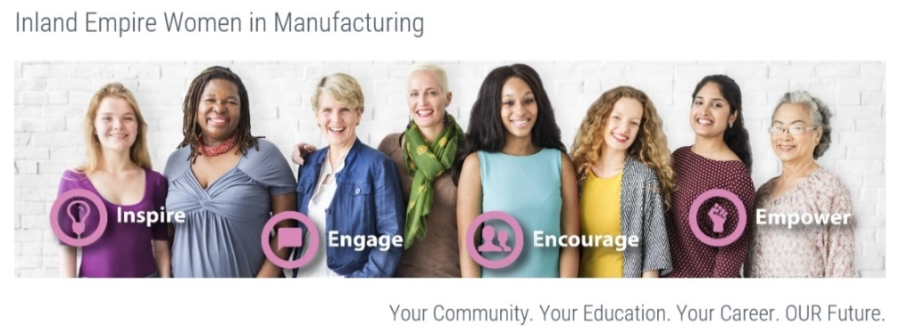
Dear Potential Sponsor:
On May 10th, 2019, the second annual “Inland Empire Women in Manufacturing” (IEwim) event will take place and we are expecting over 500 attendees!

Women are largely underrepresented in the manufacturing industry, at all levels! The goal of this event is to bring women together to support, encourage, empower, and break the stereotype of this being a male dominated industry. We have over 600,000 good paying manufacturing jobs unfilled in the USA and that number continues to climb, we need to inspire our makers and women interested in those career pathways.

Our inaugural event took place in 2018 with over 300 women and men in attendance. (Video clip= http://bit.ly/IEwimVIDEO ) Our attendees were interested in manufacturing jobs and learning more about the progression of women involved in the manufacturing industry. Along with powerful women discussing their journeys in the manufacturing world, our event provides networking opportunities with owners, managers, supervisors, community leaders and City and State representatives.

It is my hope you will consider being a sponsor for this event. We would like to provide scholarships for the women who may lack the financial means to be educated in the field of manufacturing and business. The team will structure a scholarship program named after your company/name. This is the opportunity to change lives and have your name highlighted in the program and on our website and future mailings.

Event Sponsor: $25,000 cash donation

One title sponsorship is available for the event’s largest donor. This would include title recognition in all printed materials, promotion with media, website, and future mailings.

Platinum Sponsor: $10,000 or greater cash donation.

Platinum sponsors will receive name and logo recognition in the event’s program and promotional materials, as well as throughout the event.

Gold Sponsor: $5,000-$9,999 cash donation.

Gold sponsors will receive name and logo recognition in the event’s program and promotional materials.

Silver Sponsor: $2,500-$4,999 cash donation.

Silver sponsors will receive name and logo recognition in the event program.

Bronze Sponsor: $1,000-$2,499 cash donation.

Bronze sponsors will receive name recognition in the event program.

Please mail all donations to the Inland Empire Chamber of Commerce c/o IEWIM; 3200 E. Guasti Road, STE 100, Ontario, California, 91761. For any questions, please contact Dennis Sonney (951)892-5414 or InlandEmpireWIM@gmail.com. For additional event information, please visit our website www.IEwim.com .

Thank you for your consideration.

Sincerely,

The 2019 IEwim Event Planning Committee

INLAND EMPIRE WOMEN IN MANUFACTURING

www.IEwim.com

